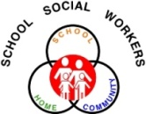**Park Hill**

**Family Connections**

**May 2013**

Pre-Register:

**United Services**: 412 Perry Tracy, MO 816-858-5153

**Platte County Health Department** 1201 East St, Parkville, MO 64152 816-587-5998

**YMCA** 8875 Clark Ave, Parkville, MO 816- 505-2622

**Park Hill Schools**

Karen DiSanto, Renner and EL, 816.359.5830

Cheryl Gunn Seidler, Southeast and Union Chapel, 816.359.6140

Carolyn Bidwell, Tiffany Ridge and Chinn, 816.359.6229

Colleen Pleiss, Hawthorn and Graden, 816.359.6560

Katherine Kraai, Congress and Lakeview, 816.359.6811

Marla Anderson, Prairie Point and Line Creek, 816.359.6379

Karen Calonge, Park Hill High, 816.359.5616

Chandra Callow, Plaza and Park Hill South, 816.359.6709

Allison Dawson, Gerner Family Early Education Ctr., 816.359.6310

Rachel Duron, Russell Jones Education Ctr., 816.359.6089

Back to School Fair

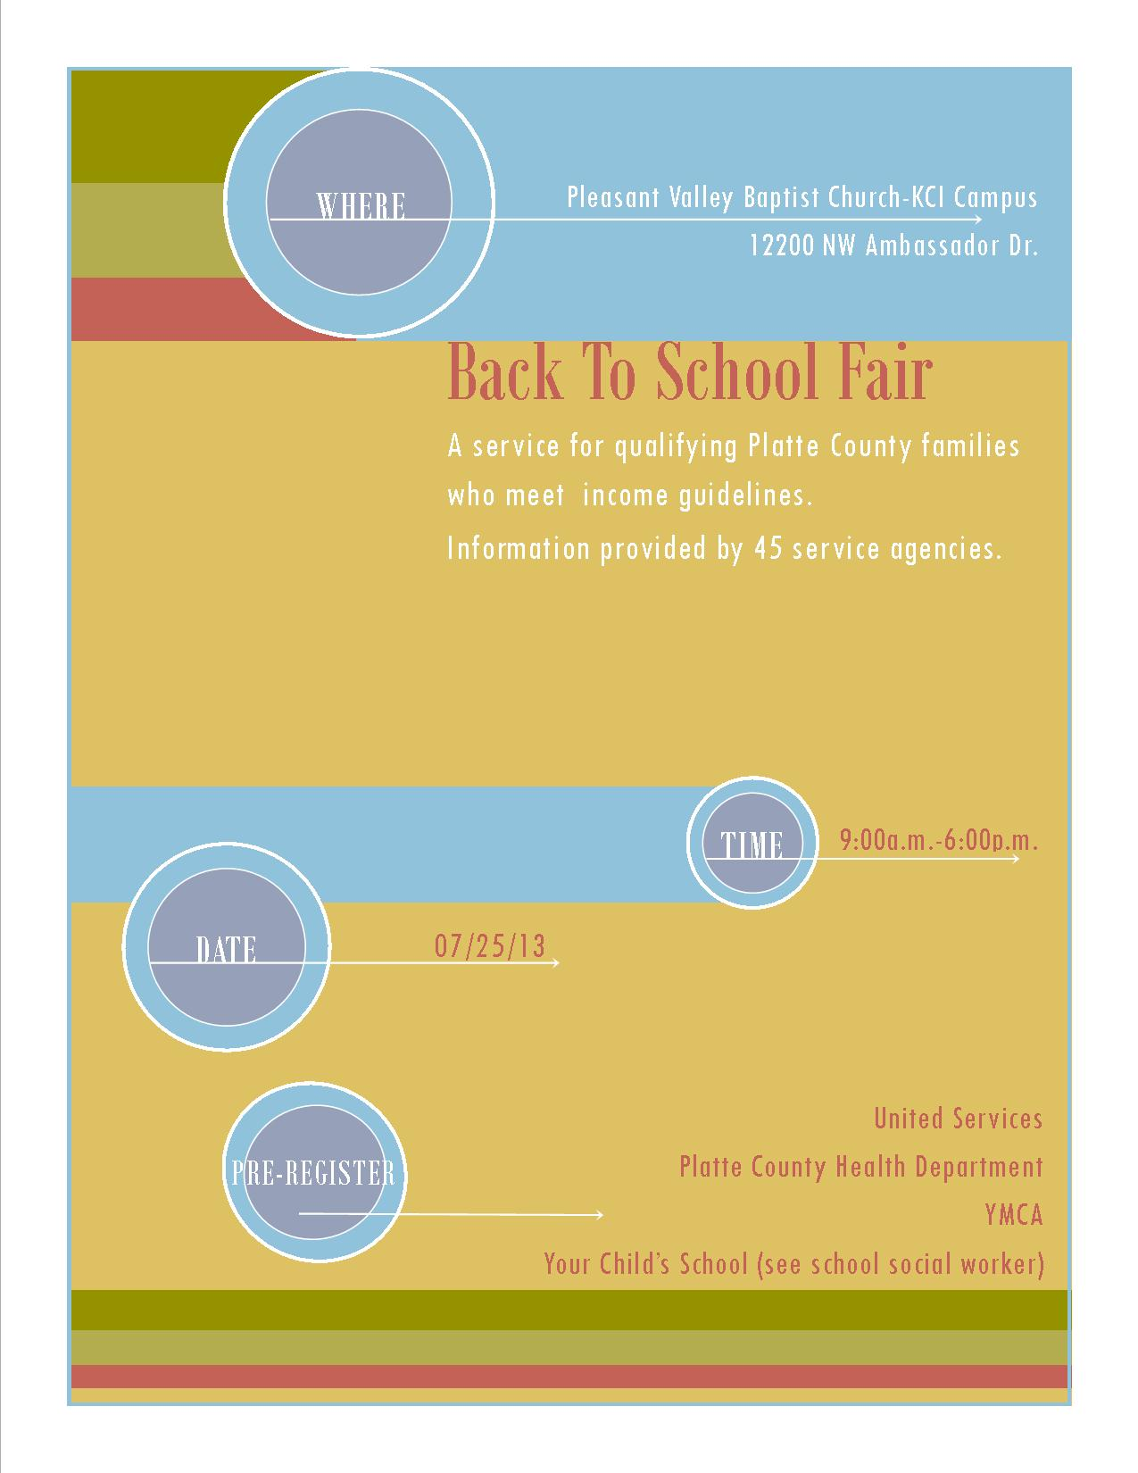

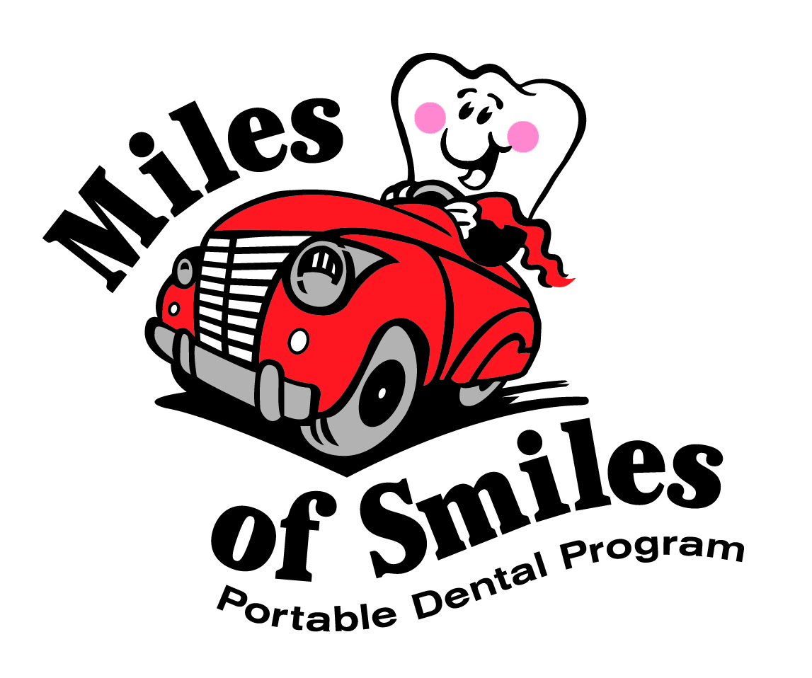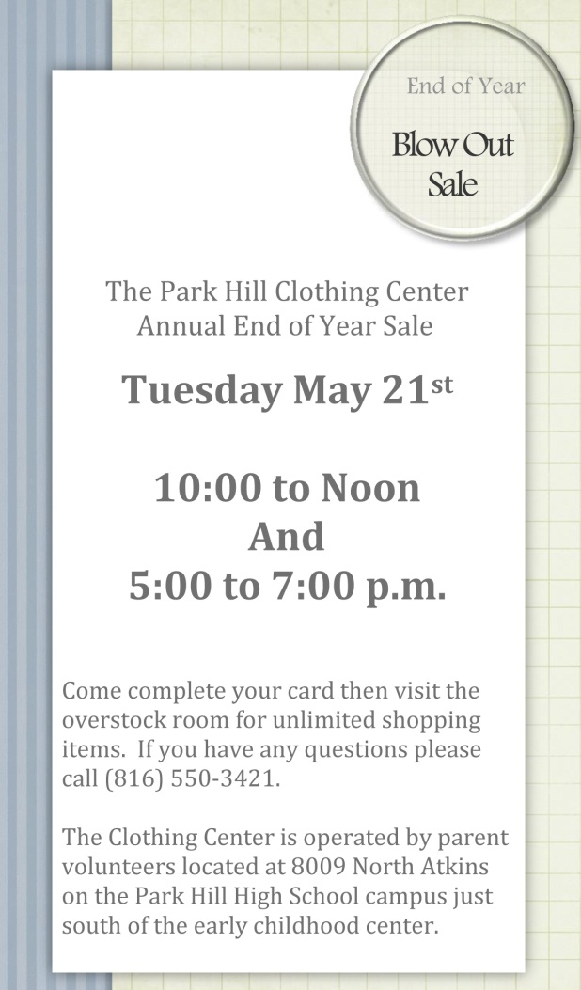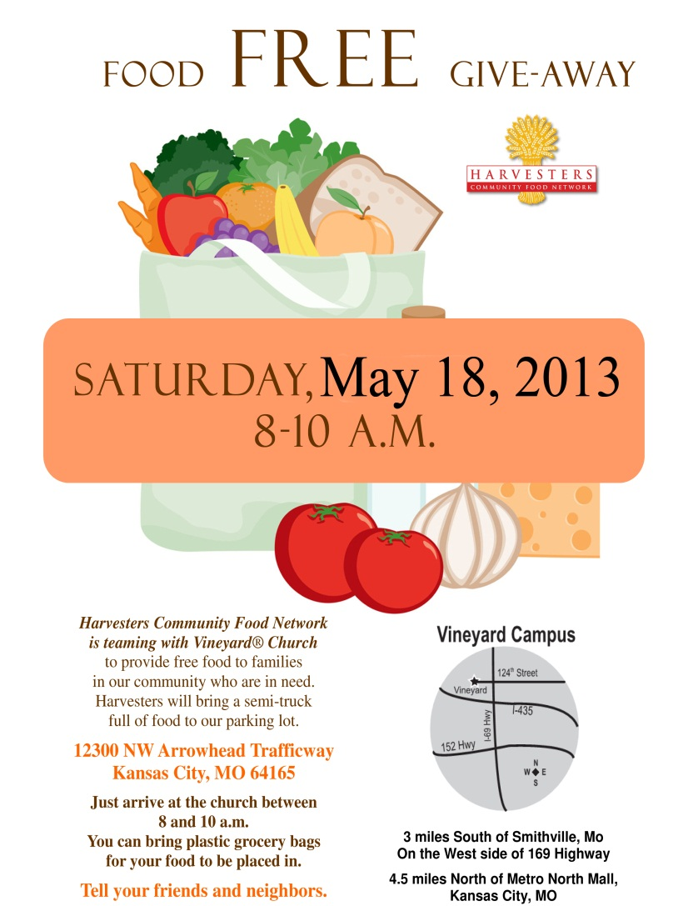

**Miles of Smiles** provides FREE dental care to children in the Northland who do not have access to dental care. The dental care is provided by a licensed

dentist and assistants, in a school setting or social service agency, church or community location for ease of access. Miles of Smiles treats children from the ages of 3 to 18, and 75% of the treatment

provided is fillings and extractions. All of our patients receive a comprehensive exam, cleaning and x-rays.

**Summer schedule**

**Call 816-413-9009 to schedule an appointment.**

Miles of Smiles

