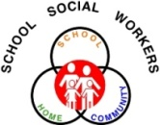

Park Hill School District

-**Family Connections**-

May 2014

**WE ARE HERE TO HELP! PARK HILL SCHOOL SOCIAL WORKERS:**

Karen DiSanto, Renner and EL, 816.359.5830 Cheryl GunnSeidler, Southeast and Union Chapel, 816.359.6140

Carolyn Bidwell, Tiffany Ridge and Chinn, 816.359.6229 Colleen Pleiss, Hawthorn and Graden, 816.359.6560

Katherine Kraai, Congress and Lakeview, 816.359.6811 Marla Anderson, Prairie Point and Line Creek, 816.359.6379

Karen Calonge, Park Hill High, 816.359.5616 Jill Hazell, Plaza and Park Hill South, 816.359.6709

Allison Dawson, Gerner Family Early Education Ctr., 816.359.6310 Rachel Duron, Russell Jones Education Ctr, 816.359.6089

**Summer Time Fun**

**The following list provides 33 free activities that offer something for everyone.**

1. [1827 Log Courthouse](http://www.visitkc.com/member-details/index.aspx?id=34817). Once the only courthouse west of St. Charles, Mo., it later served as a mercantile operation, home and gathering place for the early Mormon settlers.
2. Board of Trade Visitors’ Gallery. Observe the fast-paced world of trading.
3. [Boulevard Brewing Company](http://www.visitkc.com/member-details/index.aspx?id=10131). Tour the largest specialty brewer in the Midwest. Call for reservations.
4. [Bruce R. Watkins Cultural Heritage Center](http://www.visitkc.com/member-details/index.aspx?id=10604). A tribute to the city's early African-American pioneers.
5. [Cave Spring Interpretive Center](http://www.visitkc.com/member-details/index.aspx?id=10154). A 36-acre nature park on the Santa Fe Trail.
6. Children's Peace Pavilion. Hands-on museum focusing on world peace.
7. [City Market](http://www.visitkc.com/member-details/index.aspx?id=10163). Saturday and Sunday mornings bring one of the largest farmers markets in the Midwest.
8. [Crown Center](http://www.visitkc.com/member-details/index.aspx?id=10201). There's always something going on at this entertainment center. Check out the free outdoor movies and concerts during the summer months.
9. [Deanna Rose Children's Farmstead](http://www.artsandrec-op.org/farmstead/). A great place to see and feed an array of barnyard friends and other animals native to the area.
10. Ernie Miller Nature Center. This center was created to heighten awareness of the natural world.
11. [Federal Reserve Bank of Kansas City's Money Museum](http://www.kc.frb.org/moneymuseum/). Learn about the nation’s financial system through interactive exhibits.
12. [First Fridays](http://www.visitkc.com/member-details/index.aspx?id=34170). This 40-gallery art crawl has quickly become a local and regional favorite, drawing thousands the First Friday of every month.
13. [Frontier Army Museum](http://www.visitkc.com/member-details/index.aspx?id=30874). Focuses on Fort Leavenworth's role in westward expansion.
14. Hall of Waters Spa and Water Bar. Enjoy free samples of mineral water from the longest water bar in the world.
15. [Hallmark Visitors Center](http://www.visitkc.com/member-details/index.aspx?id=10294). Catch a behind-the-scenes peek at the world's largest greeting-card company.
16. [Harley-Davidson Vehicle and Powertrain Operations](http://www.visitkc.com/member-details/index.aspx?id=31637). Tour the facility to see how hogs are made.
17. [Haskell Indian Nations University Cultural Center & Museum](http://www.visitkc.com/member-details/index.aspx?id=34839). Preserves the vast history of Haskell's evolution from boarding school to university.
18. Heart of America Shakespeare Festival. Catch Shakespeare under the stars during a free outdoor performance (June-July).
19. [Johnson County Museum of History](http://www.visitkc.com/member-details/index.aspx?id=10341). See what has lured people to the suburbs for the past 175 years.
20. [Kaleidoscope](http://www.visitkc.com/member-details/index.aspx?id=29154). From the minds behind Hallmark, a free creative workshop for kids aged 5 to 12.
21. [Kauffman Memorial Garden](http://www.visitkc.com/member-details/index.aspx?id=32195). Showcases sculptures, fountains and colorful beds of exotic plants.
22. [Kemper Museum of Contemporary Art](http://www.visitkc.com/member-details/index.aspx?id=10386). With the famous contemporary pieces it houses, this museum is a city gem.
23. [Lakeside Nature Center](http://www.visitkc.com/member-details/index.aspx?id=32938). Learn about the natural world around through live native-animal exhibits and workshops.
24. [Lanesfield School Historic Site](http://www.visitkc.com/member-details/index.aspx?id=10393). Practice your penmanship or cipher math problems on a slate with a costumed schoolteacher in a school built in 1869.
25. [Legler Barn Museum](http://www.visitkc.com/member-details/index.aspx?id=29133). Built in 1864, this museum stands as one of the few remaining limestone barns.
26. [Liberty Jail](http://www.visitkc.com/member-details/index.aspx?id=10318). Historic site for both Clay County and the LDS Church due to the five months Joseph Smith, founder of the Mormon Church, spent here.
27. Linda Hall Library. One of the largest privately endowed scientific and technical reference libraries in the country.
28. Line Creek Archaeology Museum. Located on a 2,200-year-old Hopewell Indian site, it houses artifacts from prehistoric Native American cultures.
29. Martha Lafite Thompson Nature Sanctuary. Experience nature preservation through trails and the Nature Center.
30. [Mormon Visitors Center](http://www.visitkc.com/member-details/index.aspx?id=10450). Learn about the key role the Mormons played in the early and tempestuous history of Independence, Mo.
31. [The Nelson-Atkins Museum of Art](http://www.visitkc.com/member-details/index.aspx?id=10455). Enjoy of the finest general art museums in the country.
32. [Overland Park Arboretum](http://www.visitkc.com/member-details/index.aspx?id=35596). A 300-acre park dedicated to the preservation of indigenous plants and wildlife.
33. [Shoal Creek Living History Museum](http://www.visitkc.com/member-details/index.aspx?id=10537). A village of more than 20 authentic 19th-century buildings dating from 1807 to 1885.

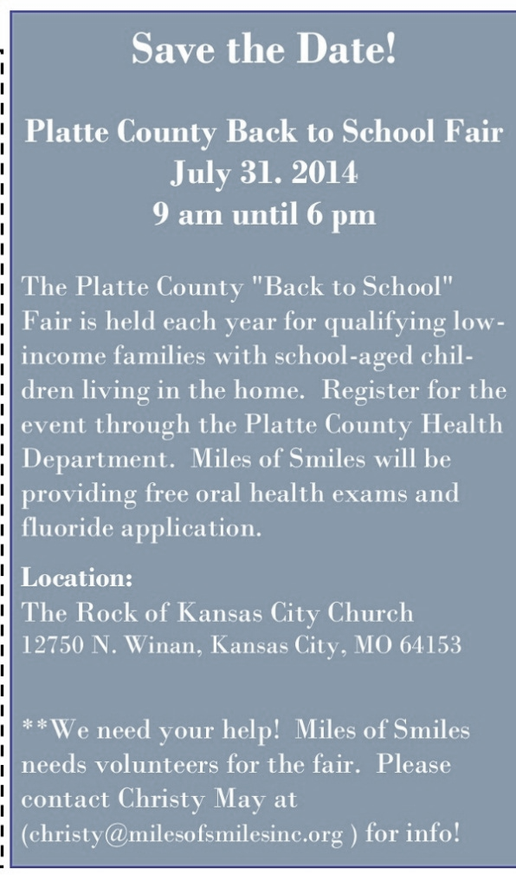

**New Location**

**The Rock of KC Church**

12750 N Winan Road

Kansas City, MO 64163

***Registration deadline is July 18th***

Pre-registration required. You can register at:

**www.choose-hope.org/2014-back-to-school-and-health-fair-form/**

If you need access to a computer or the internet please visit:

* Platte County Community Center North

3101 Running Horse Road • Platte City, MO 64079

* Platte County Community Center South

8875 Clark Avenue • Parkville, MO 64152

* United Services Community Action Agency

412 Aller Street • Platte City, MO 64079

School may be almost out for the summer but it is time to pre-register for the **2014/2015 Back to School Fair**. Space is limited. This service is for qualifying Platte County families who meet income guidelines. Information will be provided by 40 service agencies.

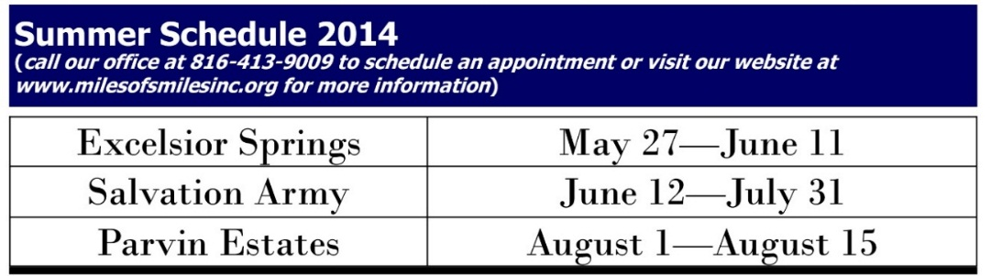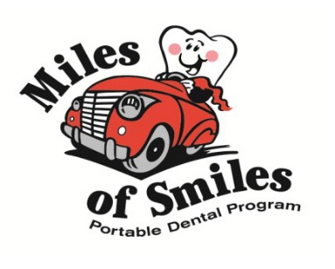

**Platte County Family Support and**

**Children’s Division**

816.858.3740

Feel free to contact them directly for any help or questions regarding: Family Health care/MO HealthNet, food stamps, temporary assistance, child care assistance and more.

**Kansas City Resources for Utility Assistance:**

Salvation Army of Platte County 816-452-5663

Good Samaritan Center 816-630-2718

Metropolitan Lutheran Ministries 816-454-5295

Northland Assistance Center 816-421-2243

United Services 816-858-5153

St. Therese 816-741-2800

**Tri-County Mental Health Services**

816.468.0400

CRISIS LINE: 888.279.8188

They provide medication services, counseling and in-home case management. You may qualify for their sliding fee scale.

**Platte County Health Department**

816.587.5998

Please contact them for any health concerns. The Health Department has appointments for individuals who are either uninsured or have MO HealthNet that reside in Platte County. They are also able to provide immunizations to individuals who qualify.